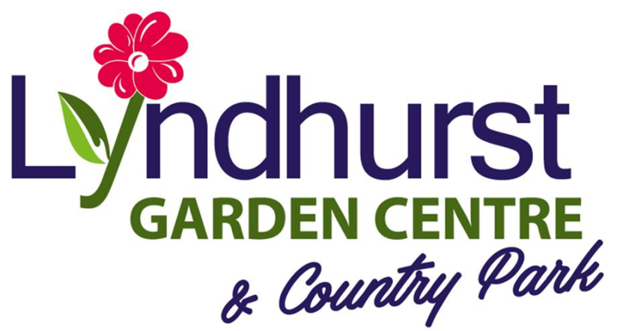

Frequently asked questions

Q. How long is the holiday home park open?
A. We have a 12 month season

Q. Is residential use of the holiday home allowed?
A. Residential use of your holiday home is not allowed under any circumstances. We are a strictly holiday only park. Owners need a permanent address elsewhere.

Q. Can I stay for long periods in my holiday home?
A. Yes, you can use your holiday home as much as you wish.

Q. Do you allow subletting?
A. Subletting is not permitted. Close friends and family can use your holiday home if introduced initially.

Q. Do you allow dogs?
A. Yes. Dogs must be kept on a lead at all times and all excrement disposed responsibly.

Q. Who is responsible for ground maintenance?
A. We maintain all grass, shrubs and flower beds. If you would like your own tubs, they must be situated on your patio or decking.

Q. Do you allow BBQ’s?
A. Yes BBQ’s are allowed but we reserve the right to prohibit them for fire and safety reasons.

Q. Is there mobile phone coverage on the park?
A. Yes, there is full coverage for the majority of networks.

Q. Is there any security on the park?
A. There are various security devices on the park including a permanent onsite warden.

Q. Is there a shop on site?
A. The site is situated next to our family run garden centre and coffee shop. There is a Co-op and a Spar shop in the village or several large Supermarkets in Skegness.

Q. Do you have a club on site?
A. No, we prefer to keep the park as peaceful as possible.

Q. Do you have a restaurant on site?
A. Yes, the garden centre has a restaurant which is open 9.30am - 4pm.

Q. What about insurance?
A. You need to arrange your own insurance and we would need a copy of the certificate annually.

Q. Do you allow children?
A. Children are allowed and we encourage parents / guardians to be actively involved in responsible supervision.

Q. What happens to the holiday home in the winter?
A. To ensure adequate frost protection for caravan holiday homes in the winter the units water system needs to be drained down. The park can offer this guaranteed service for a small charge or owners can drain down themselves at their own risk.

Q. Where is the nearest pub?
A. The nearest pub is a short walk from the park entrance and there are several more in the village, a further 10 minutes walk.

Q. Where is the nearest fishing pond?
A. There is a fishing pond next door to the park and also one opposite.

If you have any queries or questions please do not hesitate to ask

